**Database Technologies**

**UE19CS344**

**6th Semester, Academic Year 2021-22**

Week #5: Secondary Indexes

(A2)

Date: 15/2/2022

|  |  |  |
| --- | --- | --- |
| Name :  SUMUKH RAJU BHAT | SRN :  PES1UG19CS519 | Section :  H |

1. Consider the query,

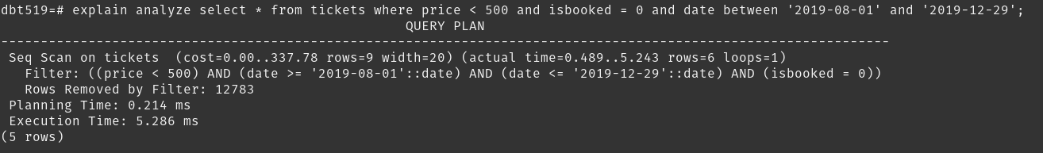We notice that there is a sequential scan of the table.

If we create a index for the attributes in the where clause using:



We can see an index added to the table. Index for primary key already set by the DBMS when it was defined:

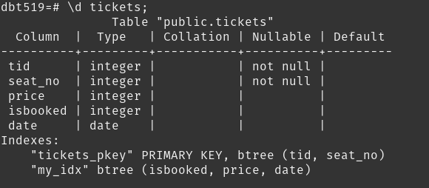

We get the following:

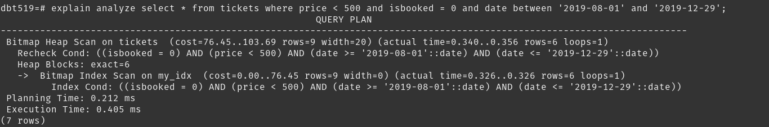We can notice now that it does an index scan using the secondary index setup. The execution time drops more than 10x than earlier.

2. Consider another query,

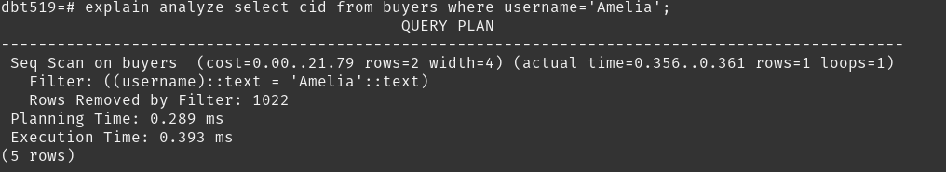It does a sequential scan to watch the string values in its columns with the given target.

We can setup an index for string attributes as well:



We can see the index being added to the table:

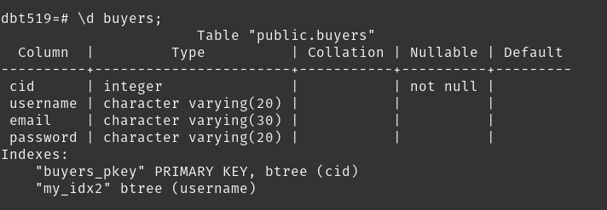

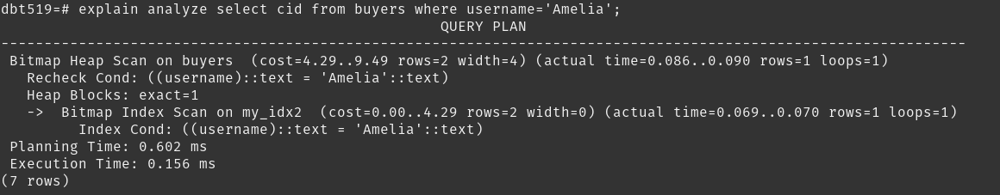

Now we can see an index scan being performed. We can see the execution speed drop 2x than before.

3. Consider another query,

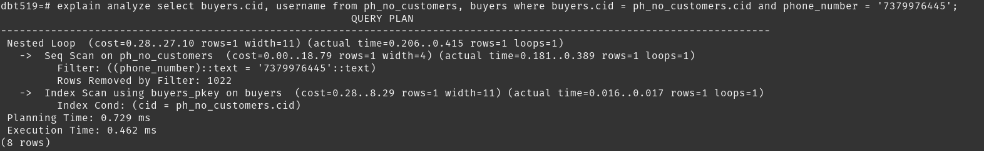Since the join condition attribute happens to be a primary key, it does a index scan for that, but a sequential scan for other attributes in the where condition of the query.

Therefore we setup the following secondary indexes:

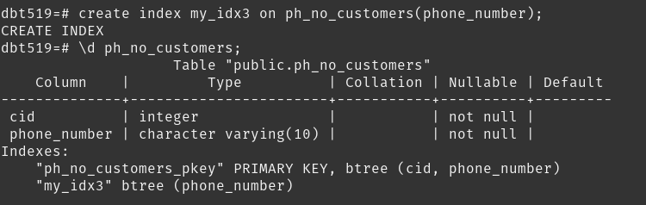

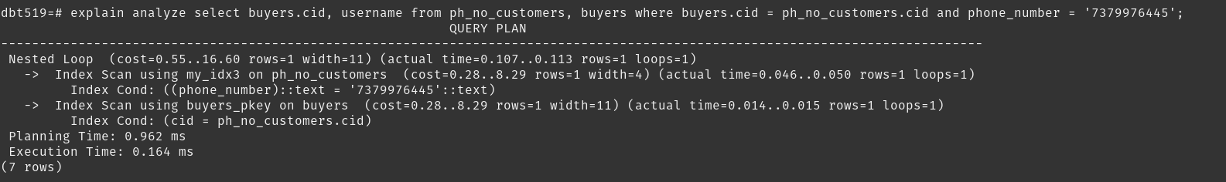Now it does index scans for all attributes. Execution time drops 2x than earlier.